**1.What is an API?**

A. The class which is already developed and which is reused in our own class to perform some operation is called API. The API is single class/program.

In Simple terms , API is a reusable class. This class is in .class file.

When the concept name is before the API, API is not single class and API is collection of classes.

Expamples:

1.Java API

2.JDBC API

3.Reflection API.

…etc.

**2.API Documentation:-** The classes are not developed by single developer. The super , sub and user classes are developed by different developers. Usually, the super classes are developed by Team leaders. Then Remaining sub and user classes are developed by Team members parallely.

The super class must be used in team member developed classes.

Doubght:-1 what are the class details?

The class details are class name, constructor signature, method name , method returning value type, Exception types which is thrown by method, method and constructor functionalities, Field names, field data types, field modifiers.

Doubght:-2 How one developer developed class details are known to other programmer?

The one developer knows other developer developed class details using special file called “API Documentation”.

**The API Documentation is a documentation file of class.** It is an html file. This file contains following information in given manner.

1. First ,It has the package name.
2. Then next class declaration with comment.
3. Then Fields Declaration.
4. Then Constructors Declaration.
5. Then Methods Declaration.
6. Finally the methods inherited from super class.

Note:- The API documentation file containes only details of public classs. Only protected and public members of class will be included in API documentaiton file.

We generate API documentation file for class using “**javadoc tool**”.

Syntax:

* Javadoc filename.java

Example:

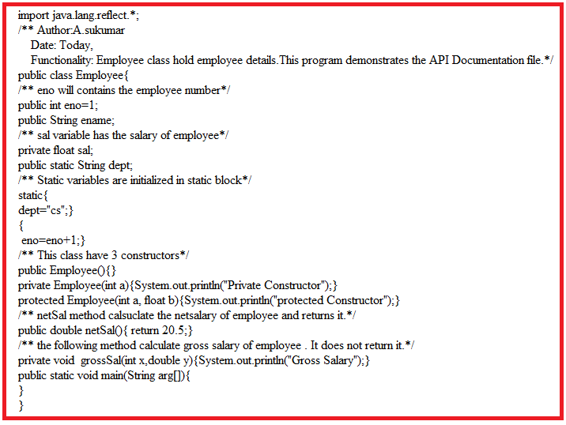

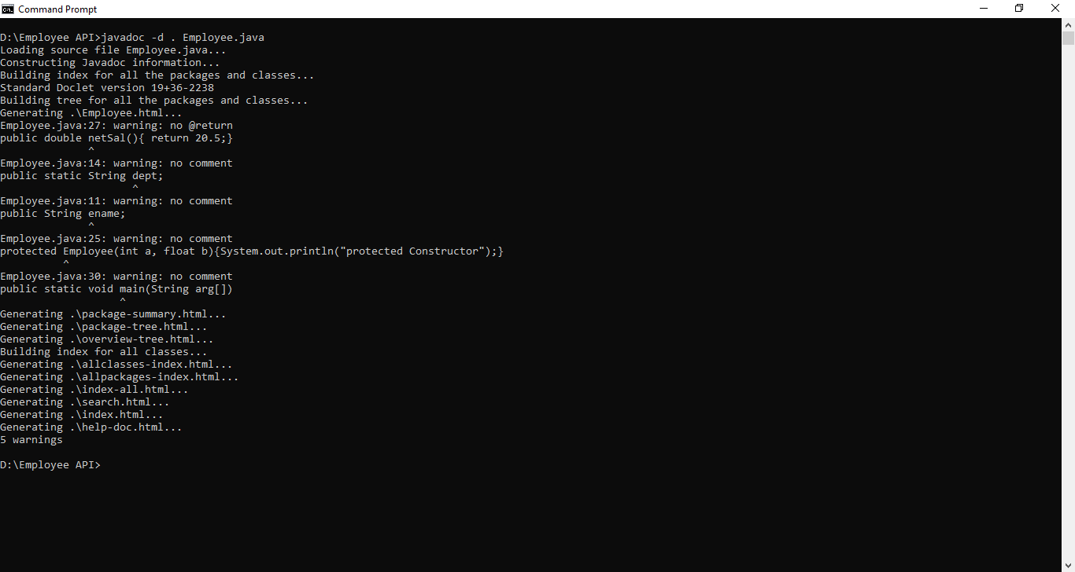

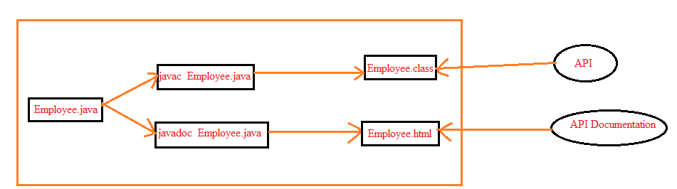

3.Difference Between API and API Documentation.

